Change Management (Fall 2015) sec. 01

Managing Change – Case Study of Dubai Customs

  - Selected Project proposal:

Dubai Customs is the First 100% Smart Department 02/10/2013
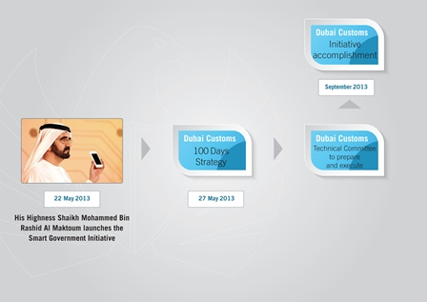
In accordance with the integrated vision of the UAE Vice President, Prime Minister and Ruler of Dubai, His Highness Sheikh Mohammed bin Rashid Al Maktoum, Dubai Customs transformed into an entirely Smart Government Department, that provides its services to the clients through mobile phones 24/7. H.H. Sheikh Mohammed described the Smart Government as “one that is readily accessible to the people and does not burden the user, one that works 24/7 and 365 days a year and provides its services through mobile phones”.
Dubai Custom is channeling its efforts towards attaining the objective of His Highness Sheikh Mohammed to transform all government departments into smart ones. Dubai Customs transformed from an e-Government Department to a 100% Smart Government Department, delivering non-stop services to customers through their mobile phones, regardless of time and place. These smart services are consistent with the Dubai Model for Government Service Delivery and in line with the service standards of Dubai Smart Government.
Dubai Customs developed an integrated system of services that not only allows clients to submit their requests through mobile phones, but also ensures the requested services are processed once the requests are received.
E-mails are sent to clients immediately after the implementation begins, informing them about the time taken for the service to be accomplished.
By taking such a procedure, Dubai Customs was able to transform into a 100% Smart Department that implements its custom transactions through the latest applications of Information Technology.
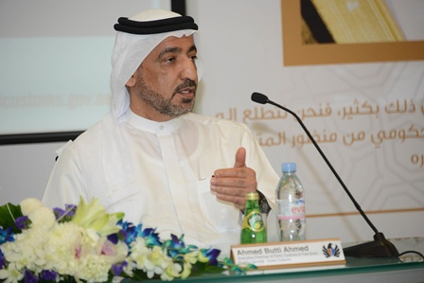
Dubai Customs is dedicated to providing its clients with added value services in the form of cost effective businesses in a shorter time and with less effort. It also eliminated the need for human resources to follow up on the implementation of customs procedures.
During the press conference organized by Dubai Customs (Today Oct 2, 2013), His Excellency Ahmed Butti Ahmed, Executive Chairman of Ports, Customs and Free Zone Corporation and Director General of Dubai Customs, affirmed the significance of His Highness’s initiative for Dubai Customs. He said :“The Smart Government Initiative, which was launched by His Highness Sheikh Mohammed bin Rashid Al Maktoum, provided us with the roadmap to move into a new phase of the development of our customs services, and for these services to be provided - as His Highness Sheikh Mohammed aspires to see - regardless of time and place.”
Butti emphasized that Dubai Customs believes that the development process should reflect the insightful vision of His Highness Sheikh Mohammed, which requires the achievement of the highest level of government services efficiency. Services must be one of the main competitive advantages that attract investors and traders and make Dubai – along with the entire UAE - a selected destination by companies and businesses which look to select a suitable market from a diverse, wide range of markets available in the region. Butti revealed that this objective was attained as Dubai made use of its distinct geographic location to link between markets.
Butti explained that Dubai Customs addressed the development of the smart government services in accordance with a 100-day plan that was set while taking into account the high competitiveness of the UAE, along with its regional and international economic role. He further elaborated upon the Department’s adoption of the smart government initiative: “That’s why we exerted every effort to elevate our general performance to fit this new stage. We started to implement a comprehensive change of all work mechanisms in Dubai Customs in order to enable the clients to submit their requests through their smart phones to get 19 main services with a variety of sub services covering all customs sectors. This procedure saves time as we reach clients rather than be reached by them, and we provide our services 24 hours a day, 7 days a week. The Customer Service Centers of Dubai Customs are now located on clients’ smart phones.”
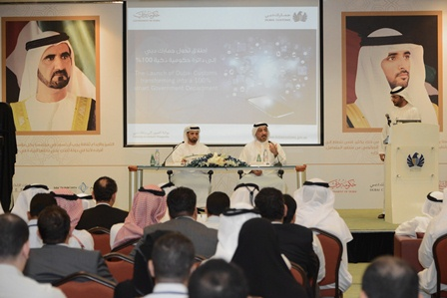
The transformation allows Dubai Customs to re-structure a part of its human resources by saving the efforts of customer service staff. This will enable the Department to make use of this labor power in other jobs that is more suitable for the new stage. Technological methods will be increasingly used to scale up staff productivity and lessen the need for customer service halls.
H.E. Ahmed Butti emphasized that as Dubai Customs was the first government department in Dubai to provide 100% of its services electronically in 2009, today it continues to lead the way as it is also the first Smart Government Department, in fulfillment of the Smart Government Initiative launched by His Highness Sheikh Mohammed bin Rashid Al Maktoum.
Butti added that the transformation of Dubai Customs into a Smart Department is not restricted to partially re-structuring human resources, it will eliminate the use of paper documents to the maximum level, and save the main original documents needed for the administrative procedures. This is regarded as one of the main goals of Dubai Customs within the framework of continuous transition to employ latest IT applications.
On the other hand, Mr. Jumaa’ Al Ghaith, Executive Director of Customs Development Division, explained that: “The development plan focused on linking requests submission through smart phones with an integrated system to follow and accomplish them. This system ensures the managers and directors in different managerial levels supervise the implementation and delivery of services in due time set in the notifications customers receive to confirm receipt of their requests.”
Dubai Customs, since the launch of the initiative, has set a higher committee in order to develop and improve the services of the smart government. The committee is comprised of all concerned divisions and departments in Dubai Customs and was responsible for the development of a comprehensive strategy to transform the Dubai Customs into a 100% Smart Department- through a series of regular meetings.
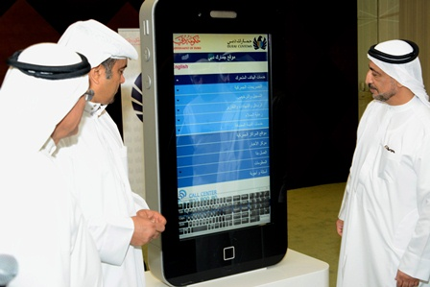
In addition to enabling Dubai Customs of providing its services through smart phones, the strategy also aims to allow the Department to make all needed changes to receive the clients’ requests non-stop 24/7. Moreover, the strategy allows the Department to begin the provision of the required services upon their receipt, through a smart system that was internally developed to enable the relevant staff to receive the requests on their own smart phones and immediately start the implementation process.
The system will allow the provision of the entire range of the services offered by Dubai Customs, a total of 19, through smart phones.
The strategy identified every step that should be taken to realize the final goal, as a work plan was approved and implemented in a timeframe of 100 days. Relevant divisions and departments were designated to carry out their duties in due time, as the Customs Development Division was responsible for the integrated technical development of customs services to be provided through the mobile site of Dubai Customs, which was designed to allow the customers send their request with the least number of steps.
Dubai Customs Department developed an integrated system of services that allows the clients to submit their requests through mobile phones, and ensures their receipt by the relevant staff on their own smart phones, who in the meantime inform the clients of the due date of the service delivery through e-mails. The requests are immediately reviewed and become subject to implementation to be delivered to customers on due dates.
Dubai Customs mainstreamed the use of these advanced technologies to achieve the maximum degree of flexibility in work procedures within the Department, where internal managerial meetings are held through video conferences without the need for managers and staff to leave their duty stations and relocate to attend the meetings. This procedure improves the performance of the staff through the best investment of working hours.
An integrated communication plan was developed to inform users and customers about the smart services provided by Dubai Customs, as they will be addressed through all means of marketing, communications, and media, including social media.
The plan aims to encourage the customers to shift to the use of smart services in order to obtain the best advantages of time and effort saving, along with lessening the need for human resources to follow up on customs transactions. Those benefits are reflected on the decrease of business costs and the increase of revenues.
Dubai facilitates its commercial and customs procedures to create more opportunities for investment, in order to stimulate the growth of trade and strengthen its leading economic role on the international level. This supports the efforts exerted to enable the UAE to be selected to host Expo 2020, thanks to its recognized competences in organizing world-class events and its position as a main destination that attracts businesses and commercial activities.

Dubai Customs main nineteen smart services:

1- Request for Client Registration
This service enables clients register their business with Dubai Customs to allow them officially and legally transact with Dubai Customs.

2- Request for Client Accreditation
This service allows clients to submit a request for enrolment in Dubai Customs Client Accreditation Program.
This Program will provide eligible clients with a higher level of services and incentives based on their profiles within Customs.

3- Request for Customs Warehouse License
This service is provided to entities requesting to have a Customs Bonded Warehouse facility where goods can be stored in the warehouse with duty deferred until they are taken for local consumption or until the expiry of the prescribed time period agreed by Customs. There are two types of warehouses, public and private warehouses.

4- Request to Record Trademark
This service allows registration of a trademark (any word, name, symbol, device, or any combination), used, or intended to be used, in trade, to identify and distinguish the brand from that of other providers , and to indicate the source of the brand.
This service allows the maintenance of Customs database for intellectual property rights after the completion of necessary procedures and prior registration with the Ministry of Economy.
Clients must request this service by filling out a Trademark registration form and submit it, to the office of intellectual property rights along with the assessed registration fees.

5- Request for Customs Declaration Clearance
This service allows the client to declare and obtain clearance for the movement of goods in and out of the emirate of Dubai under the following regimes:
-Import
-Export
-Transit
-Transfer
-Temporary Admission

6- Request for Vehicle Clearance
This service provides customers to obtain Vehicle Clearance Certificate for the vehicle they import through dubai entry points after completing the necessary clearance procedures.
This certificate is a mandatory requirement for all vehicles that need to be registered within the UAE.

7- Request for Manifest Registration
This service provide manifest for exported goods.
Clients should come with all documents to Dubai Customs operation departments in creek, hamriya, coastal berth office and dry port to validate the application and obtain the manifest.

8- Request for Guarantees/ Deposits Claims and Refunds
This service is to submit claim for refund of deposit or release of guarantee paid in lieu of Customs duty.

9- Request for Appeal
This service allows customers the opportunity to appeal any decision issued by Dubai Customs that does not fulfil their needs.
This service is the first step to be followed in order to find a way to challenge the decision provided by customs.
The customer can submit a request to appeal to resolve any issue in the following areas:
- Appeal Decisions on Customs Tariff and Restricted and Prohibited Goods
- Appeal Decisions on Origin and Economic Agreements
- Appeal Decisions on Legal Cases
- Appeal Decisions on Suspended Duties

10 - Request for Customs Opinion
This service provides recommendations and technical opinions to clients through a competent work teams in several areas per customer needs.
The focus of these recommendations and technical opinions covers the below areas:
- Customs Valuation
- Customs Tariff
- Origin and Economic Agreements
- Suspended Duties and Appeal Cases
- Suspended and Prohibited Goods

11- Requests for Letters and Certificates
This service is being offered to Dubai Customs clients who wish to obtain certificates and letters related to their trade transactions within FZ and inside the emirate.

12- Request for Transactions Report
This Service allows clients to request a history report of their customs transactions for a given period.

13- Request for Awareness and Training
This service targets customers who wish to obtain information about Dubai Customs services and procedures.
Dubai Customs organizes a wide range of awareness-raising programs and periodic training or those courses which may require accreditation of Dubai Customs Training Department.
These courses can be held at different training sites upn client preference. The following types of training courses are available:
- Awareness on Customs Valuation
- Awareness on Customs Tariff
- Awareness on Customs Origin and Economic Agreements
- Awareness on Prohibited and Restricted Goods
- Awareness on Intellectual Property Rights
- Awareness on Suspended Duties

14- Submit Complaints, Suggestions and Enquiries
This service is being offered to clients wishing to file Complaints, Suggestion or Enquiries for any service provided by Dubai Customs in order to strengthen the cooperation with clients and raise the level of performance for Services offered by Customs.

15- Submit RAFED Information
This service is specifically designed for parties wishing to share intelligence information with Dubai Customs for public safety and to help expose corruption, suspecious activities or malpractices.
This service is meant to encourage community members to help Dubai Customs in maintaining the security and stability of society.
The Identity of the submitter is kept secret according with the regulations of dubai Customs.

16- Request for Customs Audit
This service aims to allow the possibility of extracting a customs audit report for a business entity at the request of the owner or his representative.
The report provides information on imported and exported merchandise movement to/from FZ and internal movements within FZs per Customs records and includes information such as quantity, unit of measurement, weight, value for all transactions performed by the company.

17-Request for Trade Agency Registration
This service allows clients to register their agency rights with Dubai Customs. Such registration allows the agents to file complaints with specific information on violating imports by any unauthorized importers.

18- Contact Director General
This service opens a direct channel to communicate with His Excellency the Director General and provides individuals the ability to share their comments or issues they wish to have delivered directly to him.

19- Request for Inspection
This service allows clients to request the scheduling of the inspection for their cargo.

